**AI CHAT BOT**

**Developing an Intelligent Chatbot Solution for Enhanced Customer Engagement**

**ABSTRACT:**

**In recent times, companies are increasingly recognizing the value of chatbots in revolutionizing customer interactions, ensuring instant support, and ultimately boosting overall customer satisfaction. This project endeavors to develop an intelligent chatbot meticulously tailored to meet the unique requirements of our company.**

**The core objectives of this project:**

1. **Understanding Customer Needs**: Our initial focus involves conducting comprehensive research to grasp the common queries, concerns, and preferences of customers engaging with our company.
2. **Designing Conversational Flows:** Crafting seamless conversational flows is paramount. We aim to create intuitive pathways that adeptly guide users through diverse inquiries, transactions, and troubleshooting scenarios.
3. **Integrating AI Capabilities:** By harnessing the power of natural language processing (NLP) and machine learning algorithms, our chatbot will possess the capability to discern and respond to user queries with precision and efficiency**.**
4. **Personalization and Context Awareness:** We are committed to implementing sophisticated mechanisms for personalization and context awareness. This will empower the chatbot to tailor responses based on user history, preferences, and real-time context.
5. **Testing and Optimization:** Through rigorous testing and iterative refinement, we strive to optimize the performance of our chatbot solution. Our goal is to continuously enhance user experience and address any potential shortcomings effectively**.**

**HOW CAN THIS CHATBOT BE USEFUL TO THE COMPANY?**

**This chatbot holds immense potential to contribute to the growth and success of the company:**

**1. Enhanced Customer Engagement**:By offering customers a convenient and efficient channel for accessing information and seeking assistance, our chatbot enhances engagement and fosters stronger customer relationships.

**2. 24/7 Availability**: With round-the-clock support, our chatbot ensures that customers can receive assistance and information at any time, irrespective of business hours, thereby enhancing accessibility and satisfaction.

**3. Scalability and Cost Efficiency:** Through the automation of routine queries and the streamlining of customer service operations, our chatbot enables scalability and cost efficiency, freeing up resources for strategic initiatives.

**4. Data Insights and Analytics:** By capturing and analyzing interactions, our chatbot generates valuable insights into customer behavior, preferences, and pain points. These insights inform data-driven decision-making and enable us to continually refine and improve our offerings.

**TOOLS USED:**

1. **PyTorch**: PyTorch is a powerful open-source machine learning library known for its flexibility and ease of use. By leveraging PyTorch, we can develop and train sophisticated machine learning models efficiently. PyTorch provides a wide range of tools and utilities for tasks such as natural language processing (NLP), which is essential for understanding and generating text-based responses in our chatbot.

2**. Machine Learning Concepts**: Machine learning forms the backbone of our chatbot solution. We employ various machine learning techniques, including supervised learning, unsupervised learning, and reinforcement learning, to train our chatbot to understand and respond to user queries accurately and effectively.

3**. NLP Voice Tools**: Natural language processing (NLP) voice tools play a crucial role in enabling our chatbot to understand and respond to spoken language input from users. By integrating NLP voice tools such as speech recognition and natural language understanding (NLU) systems, our chatbot can accurately transcribe spoken queries into text and extract relevant information to generate appropriate responses to the users.

**BLOCK DIAGRAM:**

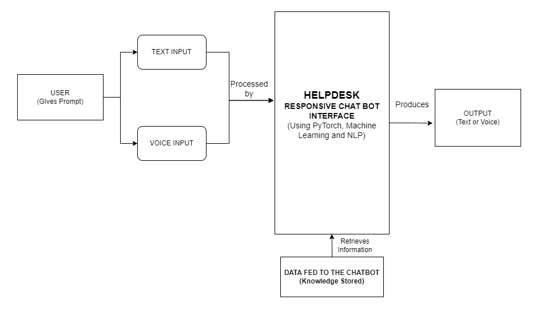

**Overall, by leveraging the power of PyTorch, machine learning concepts, and NLP voice tools, we are able to develop a cutting-edge chatbot solution that offers advanced capabilities in understanding, processing, and responding to user queries, ultimately enhancing the overall user experience and driving growth for the company.**